An integrated program of a stand-alone parabolic trough solar thermal power plant: Code description and test

Sanan T. Mohammad^{1, 2} , Hussain H. Al-Kayiem^{1,*} , Morteza K. Assadi¹ and Osama. Sabir¹
¹ Mechanical Engineering Department, Universiti Teknologi PETRONAS, 32610 Bandar Seri Iskandar, Perak, Malaysia
² Dura thermal power plant, Iraq Ministry of Electricity, Baghdad
* Sinan_taha83@yahoo.com

Abstract- Generally, the renewable energy technologies are complex due to their requirement of concepts like nonlinear simulation. This significantly applies to parabolic trough solar thermal power plants that begins with minor introductory treatment in their functioning. Therefore, this study presents a code for prediction of performances, while under-taking preliminary plant-sizing for a variety of parabolic trough solar fields operating under nominal conditions. Consequently, the conceptual design of the Stand-alone Parabolic Trough Solar involves: selection and sizing of system components, power generation cycles, working fluid types, and power block sizing. Currently, the solar thermal systems are incorporated into a turbine (flow loop), which produces steam after being energized by solar parabolic trough concentrators. This is achieved due to the in-situ measurements of the direct irradiance (DNI). However, this study presents code names PTPPP (Parabolic Trough power Plant Performance) which allows a separate calculation measures of variables including: heat loss coefficient, based on aperture area (U_{L}), predication aperture effective direct normal irradiance (I), heat gain (Q_{gain}), and the thermal efficiency of stand-alone parabolic trough solar thermal power plant in commerce. In addition, this code is able to provide a flexibility in terms of temperature, heat transfer, and pressure range.

Keywords:
Direct normal radiation; direct steam generation; parabolic trough solar thermal power plant.

1. Introduction
It is no doubt that there is a rapid increment in the demand of a clean energy globally. One of the major concerns in the world is to protect our environment through controlling pollution such as greenhouse gas emissions. Even though, the fossil energies are still available, it is not guaranteed that it will last for a long period from now. Therefore, it has become crucial to investigate alternate source of energy, in particular to renewable energy; while addressing the issues associated with environment [1]. A study predicts that there is a high expectations towards providing renewable energies of the electricity in the world by 44% in 2035 [2]. The solar power is generated using heat from the sun, then, it utilizes that source to drive an engine for heat production. This process is also associated with traditional forms of power generation; the fossil fuel combustion. It also involves fossil fuel combustion that is depending on heat engines to convert thermal energy into electrical energy. A study stated that the very first commercial station was built in the late 1980s in California [3]. Nevertheless, a drop occurred in the development and deployment of solar thermal power generation, as the natural gas prices reduced in many developed parts of the world. In the past two decades, there is a significant fluctuation in prices of gas which leads to an increase on the solar energy technology investment. With the ample amount of investments, solar thermal electricity generation has the ability to become a major source of cheap electricity generation worldwide. Furthermore, the projects that are currently proposed have a great possibility to succeed in solar thermal power technologies for electricity generation, as well as wind energy, hydropower, and optical technologies.
Due to the burning of fossil fuel, climate change has been observed. Hence, this has increased the development of more renewable energy sources worldwide. Due to the continuous decrease in the cost of photovoltaic cell PV; the solar energy-intensive concentrated solar power (CSP) industry has been competing parallel with the cost of PV. This allows CPS to store thermal energy efficiently with minimal cost as compared to solar electricity. Hence, this leads to open doors from companies that wish to convert solar energy production in the afternoon to facilitate electricity during the evening hours. Solar thermal power plants (STPPs) works under the principle of first converting solar radiation into thermal energy; then, it is processed by series of conversions to eventually generate electrical output. This thermal energy produced can be converted by working fluids such as water, air, or oil. When the concentrated solar power plants is considered, the working fluids for direct system is water, whereas for indirect system, it is oil. For the working fluids conversion, the Rankine cycle is used due to the fact that solar power generates plants that are based on four types of linear receiver: parabolic trough or Fresnel collectors, receive the focus point, such as solar towers or parabolic dish systems [4,5]. As literature describes, STPPs is highly common and economically acceptable when it is used to generate solar electricity. This is because, the plants fully utilizes the concentration of solar radiation to obtain the necessity grades for processing thermal power plant dynamics or high heat. Nevertheless, this is only applied to areas where the solar radiation is high and direct [6]. The radiation received from the sun is convertible into thermal and electrical energy. It depends on the working fluid temperatures, where the solar thermal energy conversion can be varied among lower temperatures ranges (T<100 °C), through medium temperature ranges recorded at (100 °C < T < 400 °C), and high temperatures range at (400 °C < T < 4000 °C). When low temperatures are considered, solar energy conversion uses one flat collector with water and air as fluid works, while at medium-temperature ranges; the conversion process uses vacuum collectors, and collectors with concentrates. In addition, the high-temperature conversion uses the solar plants and CSP ovens [7, 8].During the night or cloudy days, CSP stations use the thermal energy from a heat storage tank, or gas as an addition source of energy [9, 10]. Therefore, the objective of this paper is to develop and test the code capability for: (i) Calculation of overall heat-loss coefficient, (U_{L} )(ii) the prediction aperture effective direct normal irradiance (I), (iii) Calculation of heat gain for collectors (Q_{gain}) .and (iv)the prediction of parabolic trough solar power plant performance, based on CSP plants under nominal conditions. Furthermore, the performance evaluation of each plant component is carried out through real equations to provide accuracy in sizing and an adequate comprehension of the real phenomena. This process occurs in each part of the plant. Due to the code’s beneficial theoretical approach for design process and off-design calculations, the code will be enhanced in improved versions whilst providing a complete system layout optimization as it has a flexible description of the plant scheme. In addition, the power block is configured to a small scale solar parabolic trough power plan has a capacity of 1.2kW. Lastly, the plant’s primary working fluid water is through a direct steam generation (DSG). DSG-based solar parabolic trough power plant configure is shown in Figure 1.

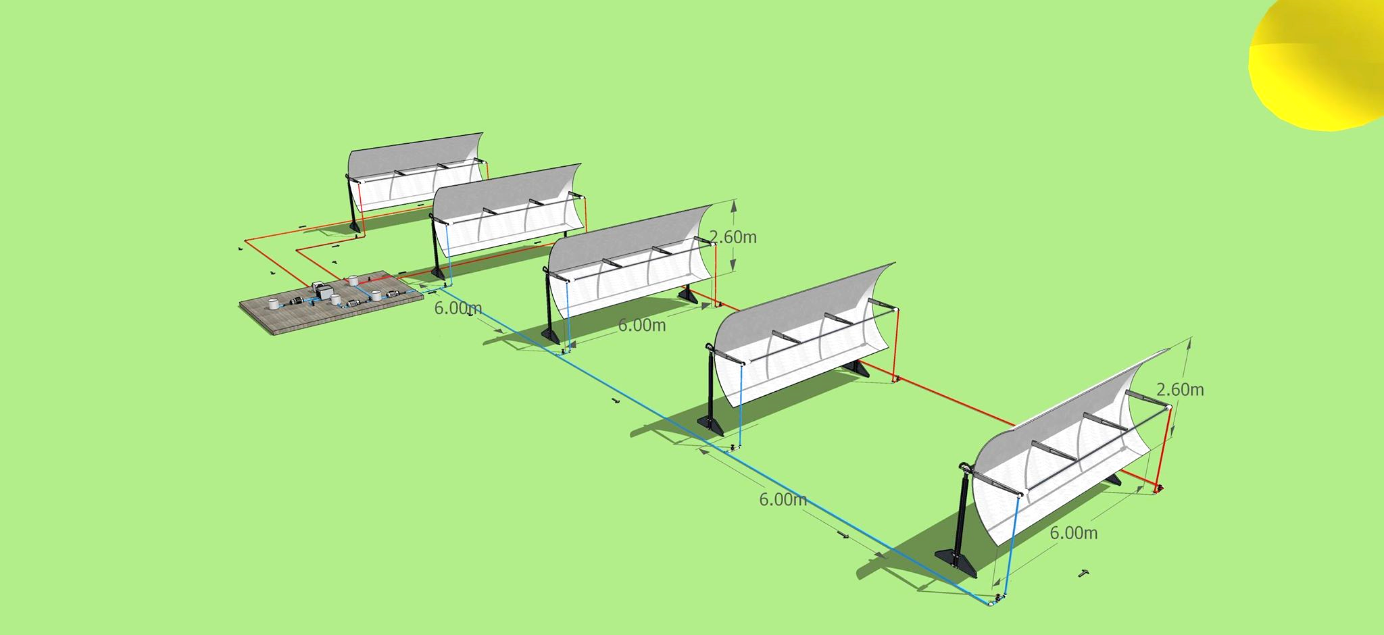
Figure 1: The proposed solar power plant established
2. Model description
The features of the present system, are:
- Estimation of Thermal performance has been carried out on hourly base.
- The capacity of the plant is 1.2 kW.
- Shading effect of receiver tube is considered negligible inside the reflector.
- The composition of collector receiver tubes includes a selective outer layer and cover glass made up of evacuated space amid in order to minimize the heat loss.
- The effect due to the accumulation of dirt and mud on the surface of reflector and glass tube is ignored.
- The solar field is made from parabolic trough collectors which have its alignment in the direction of the axis in the north to south and a tracking system in the direction of the axis in the east to west direction in order to the trace Incident radiation in the daytime.
- The steam pressure is supplied to the 1.2 kW steam turbine at 5.2 bar and 200˚C, and the condenser pressure is 0.1 bar.
- The solar field comprises of total of five trough concentrators, with specifications shown in Table 1. Every concentrator has three evacuated tubes, connected in series. Each tube is 2.136 meters in length.
- The end losses obtained from the HCE are neglected
- Circulation water pumps with maximum pressure of 6 bars pressure and 0.009 kg/s flow rate.
The diagram of solar parabolic trough concentrator is shown in Fig. 2.

4
6
5
PTC Field
F.W.P
Recirculation
Pump
Mixing Tank
2
9
1
Super heater
7
Steam
Separator
Condenser
Cooling Water
3
Generator
Turbine

Figure 2: Simplified process flow diagram a PTC based solar
thermal power plant
Table-1. Specifications of Solar collector.
Model | Symbol | High Temperature Solar Collector pipe
Brand |  | JJR-T-2140 collector tube
Length | - | 2136 mm
Working temperature (Highest) | - | > 200˚C
Diameter of absorption tube | - | 40 mm
Diameter of glass tube | - | 100 mm
Absorptivity | α | ≥ 0.95
Emittance |  | ≤0.10at temperature 200˚C
Transmittance of glass | τ | ≥ 0.91.5
Reflectance of mirror |  | 0.7
Intercept factor | γ | 0.93
Incidence angle modifier |  | 1
Optical efficiency |  | 0.57
Operating pressure (200˚C) |  | ≤ 40 bar
Design life |  | > 15( Year)
Vacuum degree of receiver tube |  | - × 10⁻⁴ Pa

3- Mathematical formulation
3.1 Modelling of parabolic trough collector
The solar parabolic trough collector has been modelled to generate power. The solar parabolic trough power plant contains both power block as well as solar collection/concentrating field. MATLab R2015a was utilized to design the solar parabolic trough field. Moreover, development of the analytical model was done to estimate its efficiency, area of the collector and annual power generated by the parabolic trough power plant.
3.1.1 Thermo-optical performance models
The analysis of energy of parabolic trough solar collector in this segment laid its foundation on the equations mostly stated in the literature. The mathematical procedure was first started with modeling of the solar system. After that, performance evaluation, for the entire system, was modelled. An assumption was made that the status of the system is fixed, i.e., steady state at the time of prediction. The transient behaviour was captured through the change of the solar irradiance and the weather conditions, which were supplied as input boundary conditions to the mathematical model. The variations in pressure were ignored apart from pressure in the turbines as well as pumps. The definition of vital rate of energy from the collector, with reference to Fig 2, is given as [11]:
= (1)
(2)
(3)
Here, the mass flow rate of water passing from the collector is denoted by and its unit is kg/s, I stand for direct normal incidence radiation on the reflector in W/m², aperture area of the collector is denoted by A_{P}, whose unit is m², U_{L} denotes the loss co-efficient based on aperture area and its unit is W/m².K, T_{m} = (T₆ + T₇)/2, is the average temperature with unit ˚C, and T_{a} is the ambient temperature in ˚C
If the work input Feed Water Pump (F.W.P) and Recirculation Water Pump (RC.W.P) and heat losses through piping are ignored then:
= (4)
From Eqs. (1) and (4), the following expression could be achieved:
(5)
It should be kept in mind that the rate of PTCs inlet mass flow normally stays firm throughout the operation. As a result, the difference of dryness factor and the average temperature will differ at the location of the load. The temperature difference could be calculated by ignoring the pump work and knowing the design point outlet dryness fraction at point 7 of PTCs field. (A.Thomas., 1996) [12] suggested 0.8 as a normal value of the dryness fraction.
The value of the PTCs field inlet temperature must be found out by keeping the inlet pressure and enthalpy at point 6.
(6)
The definition of aperture area is given as:
(7)
Where D_{co}, L, and w are collector module receiver cover outer diameter, length along with width.

3.1.2. Optical efficiency () calculation.
The estimation of the optical efficiency can be done as following [13-20]:
(8)
is the reflectance of the mirror, γ is the intercept factor, τ denotes the transmittance of the glass cover, α denotes the absorbance of the receiver whereas stands for the angle of incidence modifier for a particular PTC system. Calculation could be performed by the following equation [21.22]:
(9)

3.1.3 Overall heat-loss coefficient () calculation.
Solar collector heat loss coefficient between receiver and ambient was calculated as [13]:
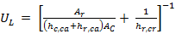 (10)
Radiation heat coefficient between the cover and ambient was calculated as:
(11)
Here denotes emittance of the cover and Stefane-Boltzmann is represented by σ. The definition of the radiation heat coefficient between the receiver and the cover is given as:
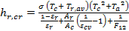 (12)
Here ε_{r} denotes emittance of the receiver and the subscript ‘av’ represents average. The definition of convection heat loss coefficient between the cover and ambient is given as:
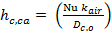 (13)
Where N_{u} denotes Nusselt number, the thermal conductivity of the air is denoted by K_{air} and subscript r denotes receiver. Temperature of the cover is given by the following equation:
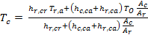 (14)

3.1.4 Calculation of efficiency
The quantity of solar radiation that shines upon the collector, given that heat is present in the system is defined as [11, 22, 23]:
+ (15)
The performance equations of the whole structure are mentioned below and power that steam turbine produces is defined as:
(16)
Here h denotes enthalpy and subscript st refers to steam. Steam Rankine cycle’s net power with its calculation is shown below:
(17)
Here W_{F.W.P} denotes power needed for the feed water pump and W_{Rc.P.W} is power for the water recirculation pump; definition of both is given as:
(18)
(19)
Efficiency of generator, solar collector field and turbine are important constraints on which the efficiency of the parabolic trough power plant () depends upon the parabolic trough power plant’s efficiency is defined by the following equation [24]:
(20)
Description of the solar multiple (SM) is given as the ratio of the thermal power generated through the solar field that is located at the point of design of the thermal power needed by the power block keeping the nominal conditions. The value 1.16 was selected for the solar multiple [25, 26]. In order to keep away from load working conditions of the power block throughout the extended cloudy weather and the times when there is no insolation, selection of solar multiple was done for the purpose of designing the solar collector field. The amount of solar multiple must be more than one to attain nominal conditions of the power block for a long duration.

3.2 – Modelling of solar parabolic trough collector field.
For approximating the performance, choosing a place with desired weather condition is very important. Several tryouts were executed before selecting a certain year, month or a day. The inputs for performance assessment on a parabolic power plant present meteorological data for the solar radiant energy as per monthly average hourly global diffused solar radiations (insolations) along with speed of the wind and air temperatures at Location. According to [26,27], long-term performance, as well as actions of the system can be examined through hourly direct normal beam insolation from existing meteorological inputs on a certain day of every month.
3.2.1. Angle of incidence ()
Definition of incidence angle is given as the angle that lies between the beam radiation on a surface and the plane that is normal to that surface, as shown in Fig 3.
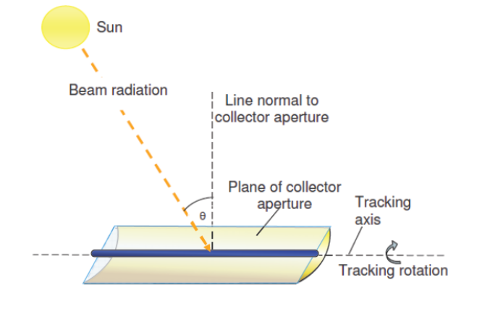
Fig.3 - Angle of incidence on a parabolic trough collector.

This angle varies over the course of the day and the outcomes obtained from the relationship among the location of the sun in the sky and the orientation of the collectors at a certain point. It is important to have knowledge of some angles to verify the position of the sun.Among these angles, one is declination angle. This angle is known to have an angular position of the sun at solar noon according to the plane of the equator. When the rotation of the Earth takes place around the Sun in a year, the declination angle varies in the range of -23.45º ≤ ≤ 23.45º as shown in Fig.4.
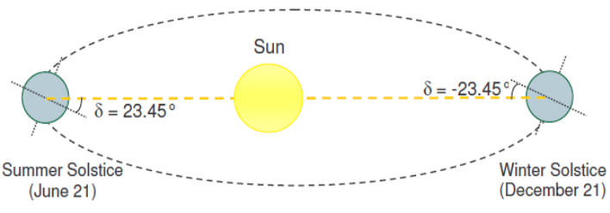
Fig.4 - Declination angle [28].

The declination angle is calculated as:
= 23.45 sin (22)
Here n stands for day number of the year (since January 1st). In addition to this, the position of the Sun relies on the angle of hour. Hour angle is the angle that lies between the local meridian and the plane that contains the centre of the Sun. When the Sun is in line with the local meridian the angle of hour has the value equal to zero. This angle arises due to the rotation of the Earth, which spins on its axis at a rate of 15° per hour and has the unit degree.
= 15 (23)
stands for solar time given in hours.
= -4( (24)
Here stands for the standard time longitude, denotes the location longitude, and E stands for time correction equation for any day of year described by [13]:
The equation of time is defined as the difference between the mean solar time and real solar time. Below is the equation of time that was used:
E= 229.2[0.000075 + 0.001868 cos – 0.032077 sin – 0.014615 cos 2 – 0.04089 sin 2] (25)
Where: = (26)
Another angle known as Zenith angle is the last angle which is needed to verify the location of the Sun. It is the complementary angle of solar altitude angle. It can be defined as the angle that lies between the line of sight to the Sun and vertical. It is linked to the hour angle as well as the declination angle through the relationship mentioned below [13, 22, and 24]:
Cos = cos cos cos sin sin (27)
Where is the latitude of the place.
Calculation of angle of incidence can be done when the value of zenith angle, declination angle along with hour angle is given. The angle of incidence for a plane that is rotated about a horizontal north-south axis having a constant east-west tracking that reduces the incidence angle can be calculated as:
Cos = (28)

3.2.2. Direct Normal beam Insolation ()
The amount of solar radiation that is not scattered and has been absorbed by the environment, arriving at the surface of the Earth is represented by the direct normal beam. The term normal here mentions the direct radiation recorded on a plane normal to its direction. The design of Direct beam Normal Insulation () is considered as average of maximum and average after 2 h of sunshine and before 2 h of sunset for a given location [24]. Furthermore, the global insolation () falling on the horizontal plane is calculated by adding the diffused insolation () and the direct beam insolation () together.
= (29)
The direct normal irradiance falling perpendicularly on the plane is calculated as:
DNI = (30)
Calculation of the aperture effective direct normal irradiance falling perpendicularly on the plane is done as:
I = DNI (31)

4. Model algorithm
MATLAB R2015a software was used to integrate the PAPPP code in order to resolve the iterative fast process for evaluations that includes pressure drops and heat losses. Firstly, defining the input data by the user is initiated: (i) the parabolic trough technology adopted by selecting the type of support structure, mirror and absorber tube, (ii) solar field is sized, the number of loops, and the length of the rows, (iii) the nominal ambient conditions in terms of temperature, relative humidity, and wind velocity, (iv) the solar field lay-out (days in a year, the position of the latitude, and the longitude, configuration), (v) Direct normal irradiation DNI import from Microsoft Excel file and (vi) the configuration and characteristics of power cycle fixing a net power output.
To elaborate how the program works; firstly, the program initiates the calculation of heat loss coefficient which is based on aperture area (UL), predication aperture effective direct normal irradiance (I). This is provides thermodynamic conditions at each point of the Rankine power cycle, hence, defining the thermal power demand and parasitic consumptions. Next, the estimations are carried out on the thermal losses occurrences, the pressure drops and HTF circulating pump consumptions. At this point, the net power output can be evaluated as the difference between the gross power output and the auxiliary power consumption. With the help of iterative procedure, it is necessary to ensure all the results match the target value defined by the user. The results of solar thermal power plant sizing at nominal conditions are used for whole plant investment cost calculation for future study. Section 3 describes the different kinds of efficiency that are adopted in order to describe the solar thermal power plant performances. Figure 5 elaborates the PTPPP architecture sketched for analytical simulation.

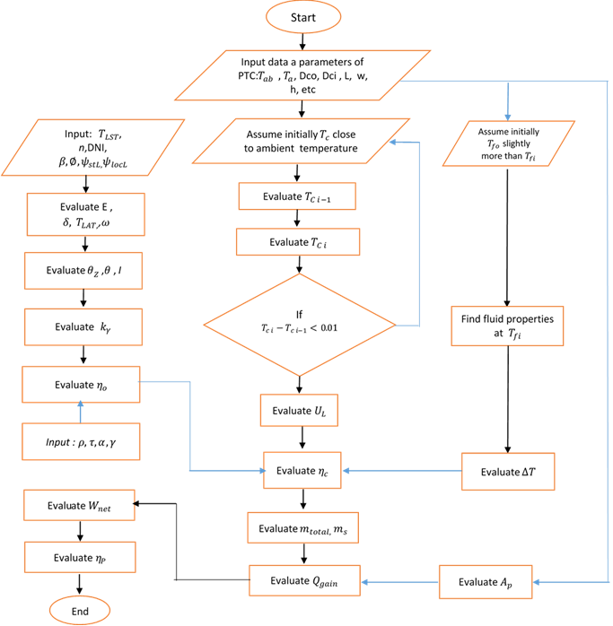
Fig 5. Algorithm solution flow chart for analytical simulation.
5. Developed Model Validation
The existing model’s validation was done by comparing the outlet Design turbine output of the simulation results obtained by [22]. The outcomes acquired from the presented model for Design DNI and mass flow, rated the performance analysis of solar power plant. Table 2 contains the specifications of solar power plant , and these are utilized for validation. The temperature of Ambient is set as 30 in order to assess the performance by authors in the existing modelling.
Table 2. Characteristics of PTC used for validation of the model [22].
Input Parameter | Value/ Type
Place | Jodhpur (India)
Collector field | Parabolic Trough Collector (PTC)
Collector field efficiency model  parameters | Collector field efficiency:  η=-  where = 0.6; = 0.2 (W/m² K)
Collector tracking mode | Focal axis N–S horizontal and E–W  tracking
Collector outlet temperature | 256 (controlled)
Ambient temperature | 30 (design value)
Willans’ line equation | Turbine power output: P =a + b. m  where a = -0.2.PD (Mavromatis and  Kokossis, 1998)  b = 686 kJ/kg
Turbine inlet pressure | 40 bar
Turbine inlet temperature | 250.4

Results of simulation were compared with the present estimations of the model for the SPTC performance where the incidence angle is at zero as displayed in Table 3. In Table 3, a well agreement for every data point that was used is mentioned. The design turbine output (MW) contained errors that were 0.61% with the average variation of 0.18%.
Table 3: Validation of present developed model with simulation Nishith data [22].
Case | Design DNI  (W/m²) | Total mass flow rate (kg/s) |  | Steam mass flow rate (kg/s) |  | turbine  output (MW) |  | % Error in turbine  output
Case | Design DNI  (W/m²) | Nishith [8]. | Model | Nishith [8]. | Model | Nishith [8]. | Model | % Error in turbine  output
1 | 540 | 2.22 | 2.21 | 1.110 | 1.109 | 0.635 | 0.633 | 0.31
2 | 550 | 2.27 | 2.29 | 1.135 | 1.145 | 0.649 | 0.653 | 0.61
3 | 570 | 2.36 | 2.38 | 1.180 | 1.190 | 0.676 | 0.679 | 0.44
4 | 580 | 2.41 | 2.42 | 1.205 | 1.210 | 0.689 | 0.690 | 0.14
5 | 600 | 2.50 | 2.51 | 1.250 | 1.255 | 0.715 | 0.716 | 0.13
6 | 610 | 2.55 | 2.56 | 1.275 | 1.280 | 0.729 | 0.730 | 0.13
7 | 620 | 2.60 | 2.60 | 1.300 | 1.300 | 0.743 | 0.742 | 0.13
8 | 630 | 2.64 | 2.64 | 1.320 | 1.320 | 0.755 | 0.755 | 0.00
9 | 640 | 2.69 | 2.69 | 1.345 | 1.345 | 0.769 | 0.769 | 0.00
10 | 650 | 2.73 | 2.74 | 1.365 | 1.369 | 0.780 | 0.781 | 0.13
11 | 660 | 2.78 | 2.78 | 1.390 | 1.390 | 0.795 | 0.795 | 0.00
12 | 680 | 2.87 | 2.87 | 1.435 | 1.435 | 0.821 | 0.821 | 0.00
13 | 690 | 2.92 | 2.91 | 1.460 | 1.459 | 0.834 | 0.833 | 0.13
14 | 750 | 3.19 | 3.18 | 1.595 | 1.592 | 0.912 | 0.909 | 0.33
Average = 0.18%
Max = 0.61%

6. Illustrative Examples
The main objective of PTPPP code is conducting an investigation on parabolic trough power plant performance. In this section, Figure 6 shows the default parameters for power plant which are recorded through a video at https://github.com/sinan1983/Advances-in-Engineering-Software/blob/master/PPTCs%203_17_2017%205_41_20%20PM.mp4 Lastly, the PTPPP code capability is investigated through simulating power cycles with stand-alone parabolic trough solar thermal power plant (1.2Kw) which is located at Universiti Teknologi PETRONAS (UTP), Ipoh, Malaysia.

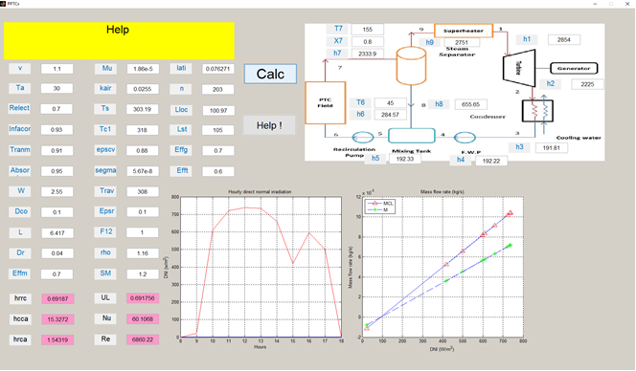
Fig 6. PTPPP software (e.g. modelling a power plant with similar units and controls, but with their own respective parameters).
Figure 7 displays the predictions recorded hourly aperture effective direct normal irradiance on the collectors. The results show that the hourly maximum aperture effective direct normal irradiance (I) is found to be nearly 650.8W/m² at 12pm.
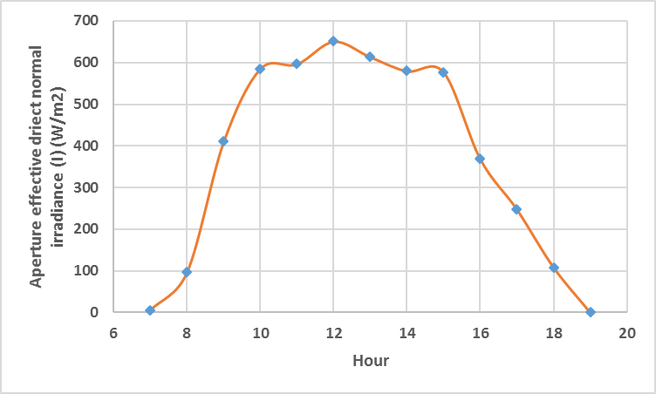
Fig. 7. Hourly aperture effective direct normal irradiance (I).

Figure 8 shows the variations of useful heat gain by the PTCs against the hourly time on a specific day of month. At 12:00pm, the heat gain is at 20000W. This is due to a higher aperture effective direct normal irradiance, which was recorded roughly at 650 W/ m².
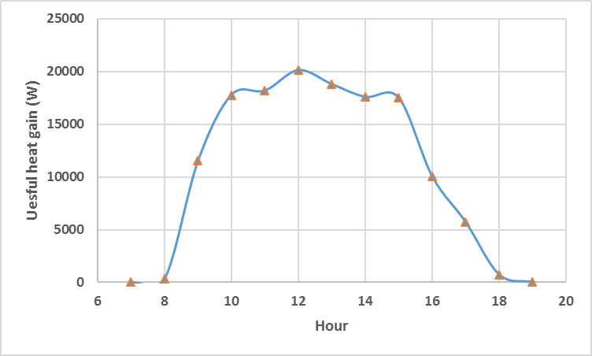
Fig. 8. Hourly collectors useful heat gain (W).
A thorough analysis of daily power output, DNI, and the efficiency for the Universiti Teknologi PETRONAS location was conducted. Figure 9 displays results on the gross electrical power output, and efficiency at a chosen day of month through the year. It clearly indicates that the gross output of the plant was maximum at higher solar radiation. In addition, the results display a maximum net power of 1700Wh and the efficiency of parabolic trough power plant is recorded at 12.85%.
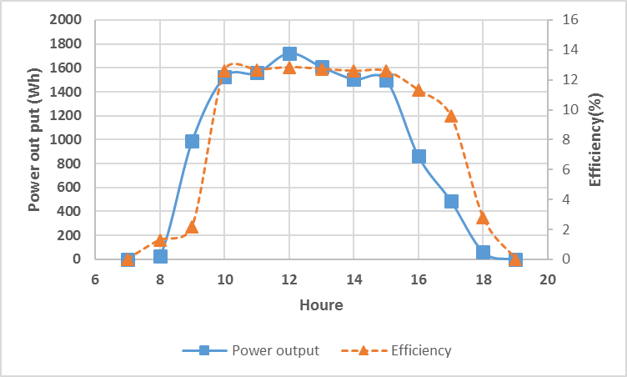
Fig. 9. The daily power output and efficiency.

7. Conclusions
To conclude, this paper highlights the development and testing of a simulation tool named PTPPP which is used for performance and thermodynamic assessment of stand-alone parabolic trough solar power plant. In addition, it focuses on the nominal efficiency where the code is applied for performance evaluation of the entire plant. With respect to a detailed thermofluidynamic model of parabolic trough collectors, it allows to predict thermal efficiency of system in commerce. Not only that, it combines components of several commercial systems to exploit distinguish technology solutions, which includes combination of mirrors, receivers, and supports. As discussed earlier, the testing of PTPPP was carried out at commercial technology plant as parabolic trough power plant in Universiti Teknologi PETRONAS (UTP), Malaysia; and it has shown a great consistency with data obtained for design performances. Furthermore, the code is designed to perform at a steady-state nominal condition, which is useful for various reasons: 1) preliminary sizing and efficiency of the entire plant, 2) comparison amongst different technologies, and 3) plants schemes through thermodynamic performances. For future developments towards the model, it will focus more towards part load performances and transient simulations. This is to reproduce real working conditions, and obtain actual electricity production under effective solar radiation data.

Acknowledgements.
The authors would like to acknowledge Universiti Teknologi PETRONAS (UTP) for the technical and logistic support to produce the article. In particular, the main author expresses his appreciation to the Ministry of Electricity in Iraq for permitting him the study leave for his PhD study. Also, he expresses his grateful to UTP for the Tuition Fees Assistance (TFA) to conduct his PhD degree.

Required Metadata

Current code version
Ancillary data table required for subversion of the codebase. Kindly replace examples in right column with the correct information about your current code, and leave the left column as it is.

Table 4 – Code metadata (mandatory)
Nr | Code metadata description | Please fill in this column
C1 | Current code version | V1
C2 | Permanent link to code/repository used of this code version | https://github.com/sinan1983/Advances-in-Engineering-Software.git
C3 | Legal Code License | MIT License
C4 | Code versioning system used | git
C5 | Software code languages, tools, and services used | MATLAB
C6 | Compilation requirements, operating environments & dependencies | https://github.com/sinan1983/Advances-in-Engineering-Software.git
C7 | If available Link to developer documentation/manual | https://github.com/sinan1983/Advances-in-Engineering-Software.git
C8 | Support email for questions | ofasabir@gmail.com

References.
[1] Taqiy eddine Boukelia and Mohamed-Salah Mecibah. Parabolic trough solar thermal power plant: Potential, and projects development in Algeria. Renewable and Sustainable Energy Reviews 21 (2013) 288–297.
[2] World Energy Outlook, IEA, Paris, France 2011.
[3] Poullikkas.A. Economic analysis of power generation from parabolic trough solar thermal plants for the Mediterranean region—A case study for the island of Cyprus. Renewable and Sustainable Energy Reviews 13 (2009) 2474–2484.
[4] Jamal .M.S, Abd Rahman.A, Shamsuddin.A.H. Advance in the integration of solar thermal energy with conventional and non-conventional power plants. . Renewable and Sustainable Energy Reviews 2013; 20:71–81.
[5] Manzolini.G, Giostri.A, Saccilotto.C, Silva.P, Macchi.E.. Development of an innovative code for the design of thermodynamic solar power plants part A: Code description and test case. Renewable Energy (2011; 36: 1993-2003.
[6] AL-SAKAF.O. APPLICATION POSSIBILITIES OF SOLAR THERMAL POWER PLANTS IN ARAB COUNTRIES. Renewable Energy1998; 14:4-9.
[7] Pavlovi´c T, ˇCabri´c B. Physics and techniques of solar energy. Belgrade: Gra – devinska knjiga; 2007 [in Serbian].
[8] Fernández-García A, Zarza E, Valenzuela L, Pérez M. Parabolic-trough solar collectors and their applications. Renewable and Sustainable Energy Reviews 2010; 14(7):1695–721.
[9] Sharma A. A comprehensive study of solar power in India and World. Renewable and Sustainable Energy Reviews 2011; 15(4):1767–76.
[10] Kaygusuz K. Prospect of concentrating solar power in Turkey: the sustainable future. Renewable and Sustainable Energy Reviews 2011; 15(1):808–14.
[11] Nishith BD, Shireesh B K, Santanu B “Optimization of design radiation for concentrating solar thermal power plants without storage’’ Solar Energy,vol , 107, pp, 98–112,2014.
[12] Thomas A. Solar steam generating systems using parabolic trough concentrators. Energy Convers Manage 1996; 37:215–45.
[13] Duffie J, Beckman W. Solar engineering of thermal processes. John Wiley & Sons, Inc.; 2006.
[14] Guven HM, Bannerot RB. Determination of error tolerances for the optical design of parabolic troughs for developing countries. Sol Energy 1986; 36:535–50.
[15] Yilmaz IH, Soylemez MS. Thermo-mathematical modeling of parabolic trough collector. Energy Convers Manage 2014; 88:768–84.
[16] Padilla RV, Demirkaya G, Goswami DY, Stefanakos E, Rahman M. Heat transfer analysis of parabolic trough solar receiver. Applied Energy 2011; 88 (12):5097–110.
[17] Odeh SD, Morrison GL, Behnia M. Modelling of parabolic trough direct steam generation solar collectors. Sol Energy 1998; 62(6):395–406.
[18] Mokheimer EMA, Dabwan YN, Habib MA, Said SAM, Al-Sulaiman FA. Technoeconomic performance analysis of parabolic trough collector in Dhahran, Saudi Arabia. Energy Convers Manage 2014; 86:622–33.
[19] Jradi M, Riffat S. Year-round numerical simulation of a parabolic solar collector under Lebanese conditions: Beirut case study. Int J Ambient Energy 2013; 35:164–79.
[20] Marif Y, Benmoussa H, Bouguettaia H, Belhadj MM, Zerrouki M. Numerical simulation of solar parabolic trough collector performance in the Algeria Saharan region. Energy Convers Manage 2014; 85:521–9.
[21] Forristall R. Heat transfer analysis and modelling of a parabolic trough solar receiver implemented in engineering equation solver. NREL/TP-550-34169; 2003.
[22] Nishith B D, Santanu B. Optimization of concentrating solar thermal power plant based on parabolic trough collector. Journal of Cleaner Production 2015; 89:262-271.
[23] Al-Sulaiman, F.A. Energy and sizing analyses of parabolic trough solar collector integrated with steam and binary vapor cycles. Energy 2013; 58: 561-570.
[24] Reddy, K.S., Kumar, K.R. Solar collector field design and viability analysis of stand-alone parabolic trough power plants for Indian conditions. Energy Sustain. Dev 2012; 16, 456-470.
[25] Montes MJ, Abanades A, Martinez-Val JM, Valdes M. Solar Multiple optimization for a solar-only thermal power plant, using oil as heat transfer fluid in the parabolic trough collectors. Solar Energy 2009; 83:2165–76.
[26] Adel M. Performance and Economics of a Solar Thermal Power Generation Plant in Jubail, Saudi Arabia: Parabolic Trough Collector. IEEE International Energy Conference 2010.
[27] Klein SA. Calculation of monthly average insolation on tilted surface. Sol Energy 1977; 19:325.
[28] http://mcensustainableenergy.pbworks.com.

Nomenclature
A_{p} aperture area (m²)
D_{ci} glass cover internal diameter (m)
D_{cog} g lass cover external diameter (m)
E time correction equation in minutes
h Enthalpy of state (kJ/Kg)
: Radiation heat coefficient between the cover and ambient W/m² C.
: Radiation heat transfer coefficient between the receiver and the cover W/m² C.
: Heat loss coefficient between the cover and ambient W/m² C.
I aperture effective direct normal irradiance (W/m²)
I_{g} global insolation (W/m²).
I_{d} diffused insolation (W/m²).
I_{b} direct beam insolation (W/m²).
K_{air} effective thermal conductivity of air (W/m K).
angle of incidence modifier.
L length (m).
m fluid mass flow rate (kg/s).
n day of year.
Nu_{o} Nusselt number.
Q_{gain} useful heat gain (W).
T_{a} ambient air temperature (K).
cover temperature(K).
T_{sky} sky temperature (K).
U_{L} overall heat-loss coefficient (W/m² K).
V wind speed.
W aperture width (m).
x the dryness fraction.

Abbreviations
CSP concentrating solar power
DSG direct steam generation
DNI direct normal irradiance (W/m²)
HTF heat transfer fluid
PTC parabolic trough collector
Re Reynolds number
SM ratio of the thermal power generated through the solar field
STPPs solar thermal power plants

Greek symbols
α absorbance of the receiver
γ intercept factor
τ transmittance of the glass cover
solar time
fluid density (kg/m³)
reflectance of the mirror
θ Angle of incidence
θ_{z} Zenith angle
latitude of the place
δ declination angle
η efficiency of PTC
efficiency of turbine
efficiency of generator
efficiency of the parabolic trough power plant
optical efficiency
emittance of the cover
ε_{r} emittance of the receiver
σ Stefane-Boltzmann constant
dynamic viscosity (Ns m⁻²)
ω hour angle

